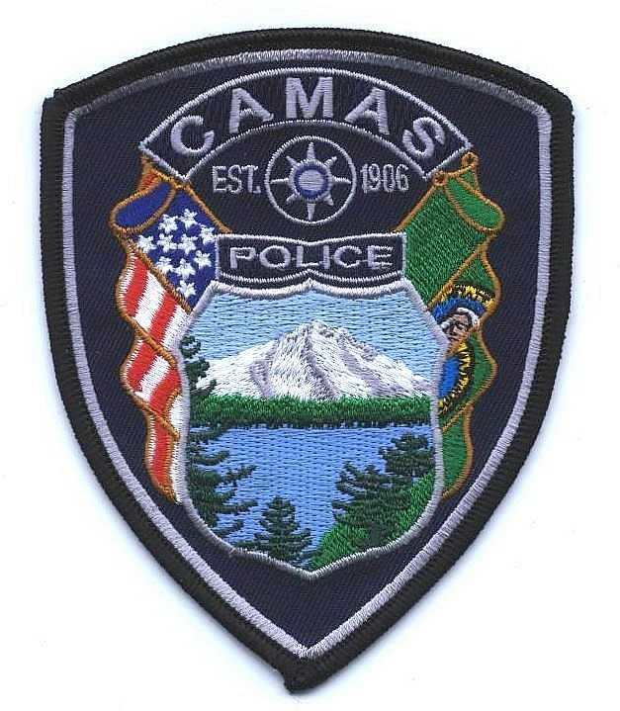
Camas Police Department
MEMO
March, 2022
To: Chief Lackey
From: Captain Nelson
Subject: Pursuit Review for 2021

There were two pursuit reviews in 2021, with each pursuit having a different initiating officer. Both pursuits were a result of attempted traffic stops.

Administrative Review 21-05
An officer observed a defective headlight on a vehicle and attempted to stop the vehicle. Upon activating her overhead lights, the vehicle accelerated. Her realization that the car was fleeing and her decision to not pursue was captured in one single radio transmission to dispatch. The entire event was approximately 17 seconds and covered 1/3 mile. The suspect was never identified and the officer followed all policies.

Administrative Review 21-12
An officer attempted to stop a speeding vehicle. The vehicle continued at a high rate of speed and blacked out (2230 hours). The officer did not initiate a pursuit. The vehicle crashed shortly after the attempted stop and the driver fled on foot. The driver was located a few blocks away and arrested for multiple charges. While the officer did not initiate a pursuit, the officer did not come to a full stop to terminate the pursuit as outlined in policy. Rather, the officer statements and AVL data show the officer continued to drive at slow speeds. There was a sustained finding against the officer for improper termination of a pursuit.

